**Applied Electronics Logbook**

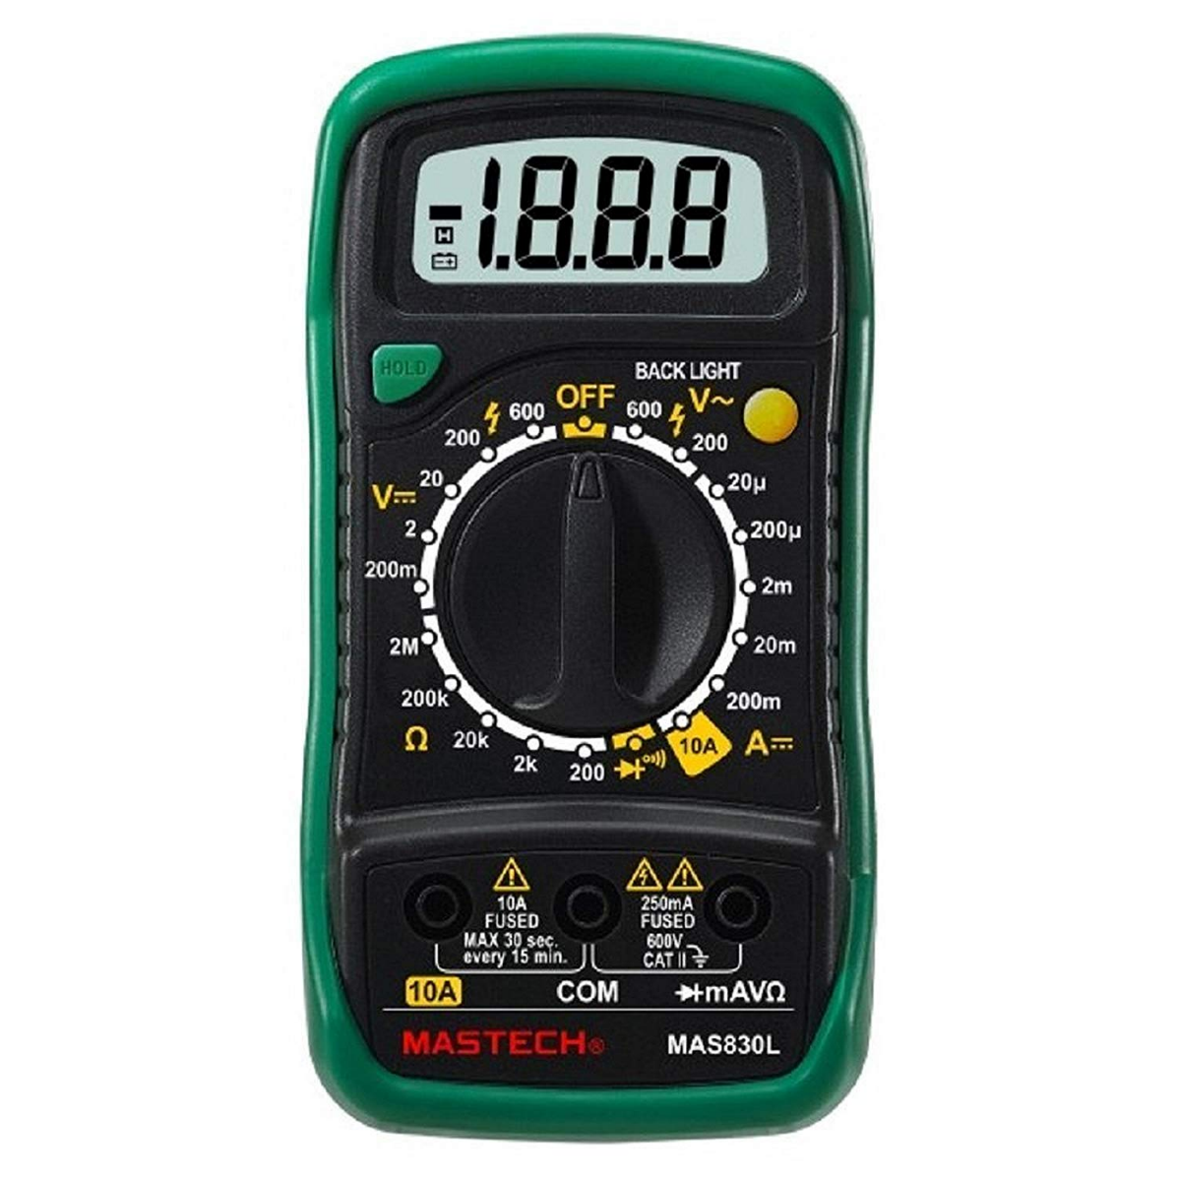

**Eleazar Arnold**

**Contents**

* **Objectives**
* **Weeks 1-2**
* **Week 3**
* **Weeks 4- 8**
* **Weeks 9-10**
* **Week 16**
* **Week 19**
* **Week 20**
* **Week 31**

**Objectives**

**I will create a device that can be used as a multimeter and a function generator**

It will:

1. Use an Atmel ATMega328 microcontroller as the computational element

2. Run from a power supply between 8V and 14V (I will be using 9V).

3. Have two D.C ranges able to measure voltages between 0-2V to 2 decimal places with a minimum of 10% accuracy, and 0-20V to 1 decimal place with a minimum of 10% accuracy.

4. Have one A.C range between 0-20V peak-to-peak (sinusoidal) to 1 decimal place, to 10% accuracy.

5. Function generator that produces sinusoidal output variable between 200Hz-7kHz at 5Vpp.

6. Display all information on a 2x16 character LCD display.

7. Be no bigger than a half-Eurocard (100mmx80mm)

Milestone 1  
• To meet Milestone 1, the microcontroller section along with mode/range selection  
switches need to be complete, tested and recorded in your journal by the end of  
Week 4.

Milestone 2  
• To meet Milestone 2, the DC 0-2V range needs to be complete, tested and  
recorded in your journal by the end of Week 7.

Milestone 3  
• To meet Milestone 3, the DC 0-20V range needs to be complete, tested and  
recorded in your journal by the end of Week 10.

Milestone 4  
• To meet Milestone 4, the AC 0-20V range needs to be complete, tested and  
recorded in your journal by the end of Week 16.

Milestone 5  
• To meet Milestone 5, the function generator including all filters needs to be  
complete, tested and recorded in your journal by the end of Week 19.

Milestone 6  
• You will be sending your completed PCB design to a board house for manufacture.  
You will do this yourself, with guidance from us or from our technicians. Our  
technicians will be able to check and confirm your board design is suitable for  
manufacture. We will then guide you through the process of submitting them for  
manufacture.

• Thus, to meet Milestone 6, all CAD work for the final design (including schematic  
and layout) needs to be completed. The resulting Gerber files need to be submitted  
for university-organized manufacture by the end of Week 24. Thus, you can send  
outr If you hit this milestone the university will reimburse you for the cost of  
manufacture of your PCB. You will have to pay up front, but the university will  
reimburse you up to a maximum of £10, which should cover the cost of your board.  
Our technicians will check your Gerbers and walk you through the process of  
submitting this to the board house (see the coursework specification document for  
further details). If you are late with Milestone 6, there is no mark penalty, as it is  
very likely you won’t get your boards back in time - and that is penalty enough!

**(This information above has been extracted from the assessment specification)**

**Week 1-2**

**Overview**

I attached two breadoards together.

I attacted the Atmel ATMega328 microcontroller onto the breadboard I made.

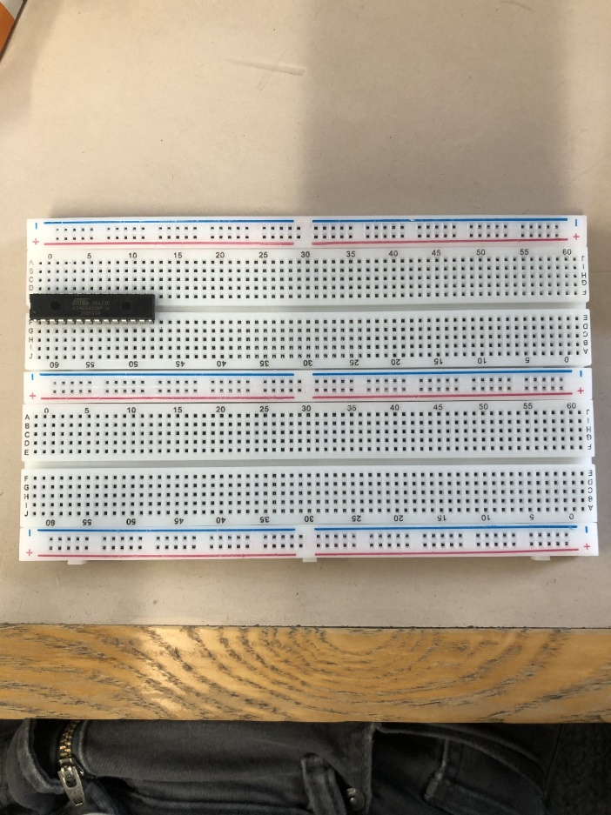However on the PCB (final version) I will be using the 32 pin version, and it will be a surface mount device.

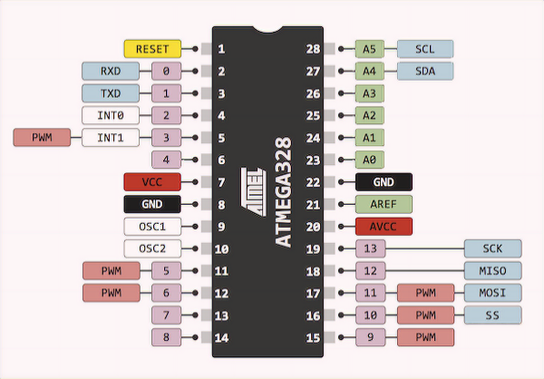**What is the microcontroller?**

The microcontroller is the ‘brain’ of an elctronic circuit. This could be thought of as more of a primitive CPU.

The Atmel ATMega328 is an 8 bit microcontroller, which has 32 KB of flash memory. It is used on boards such as the Arduino Uno. The one on the breadboard has 28 pins, and will be supplied with more or less 5V.

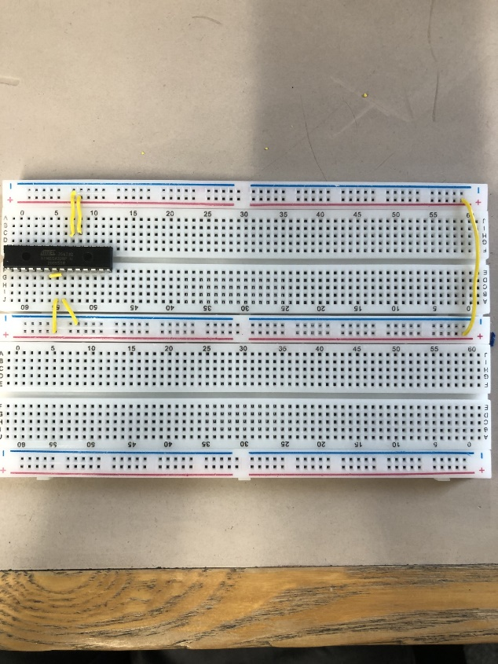

I connected the microcontroller to live and ground.

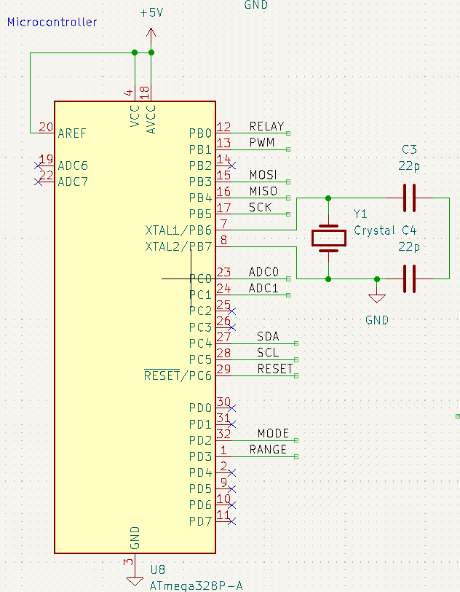

**What does the crystal oscillator do?**

The crystal oscillator uses a quartz crystal as a clock. It does this as quartz is a piezoeletric material, which means it can convert electrical energy to mechanial energy (and vise versa). Its used to have a precise electrical signal.

The piezoelectric effect occurs when a force is exerted on a quartz crystal (such as squeezing or bending it), the crystal structure deforms slightly. This deformation causes a redistribution of charges within the crystal lattice, resulting in an electric potential across its surface.

Alternatively, is applying a potential difference across the quartz crystal, the shape can be deformed.

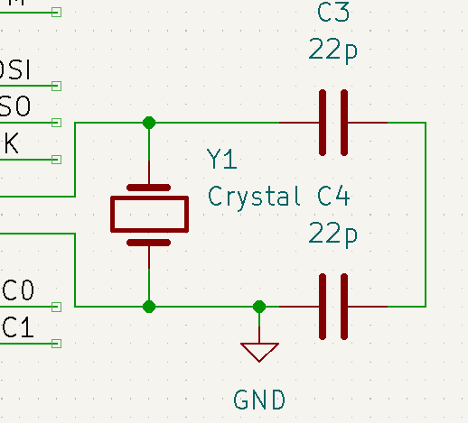

**Reset**

This resets the microcontroller if the line is altered.

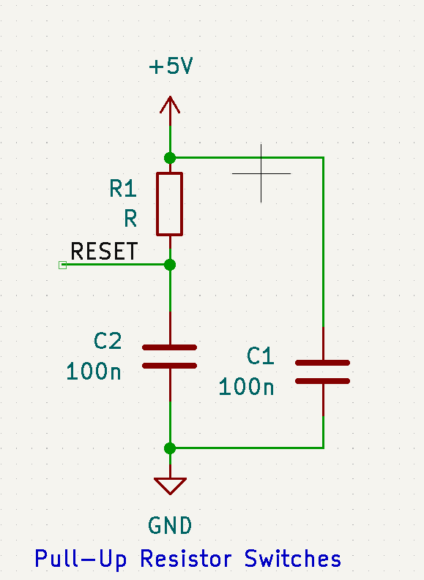

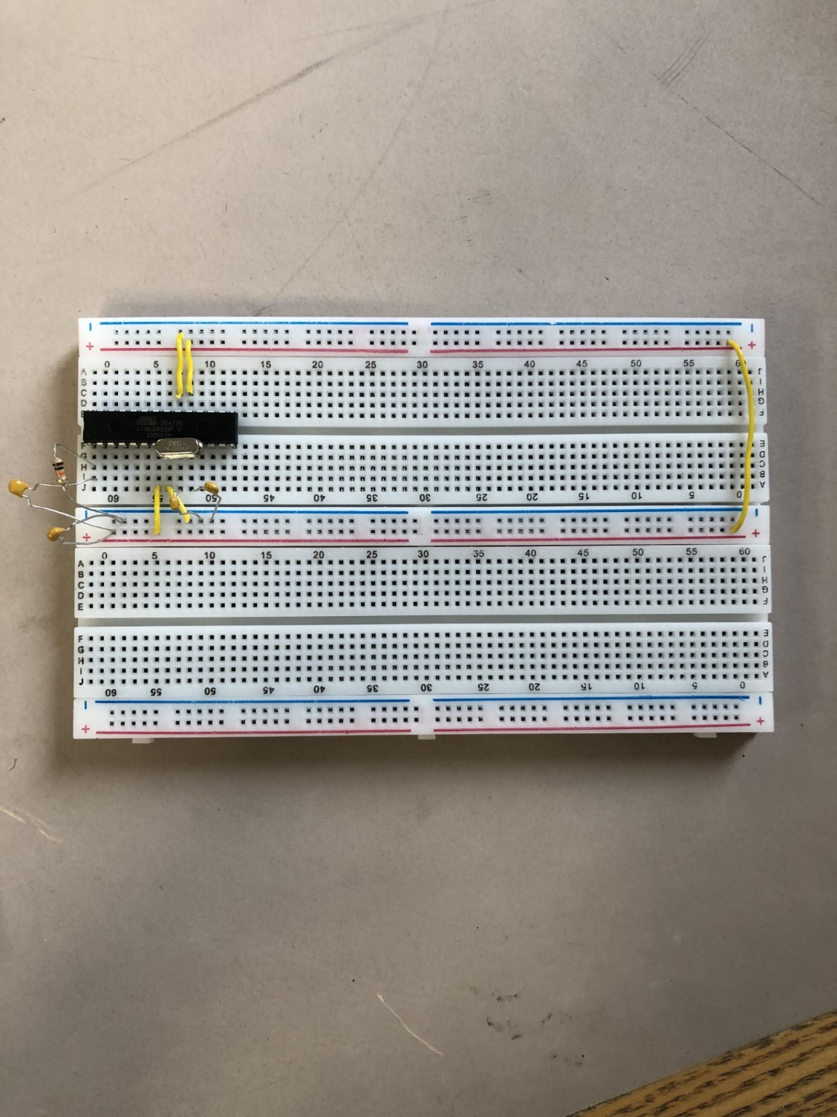

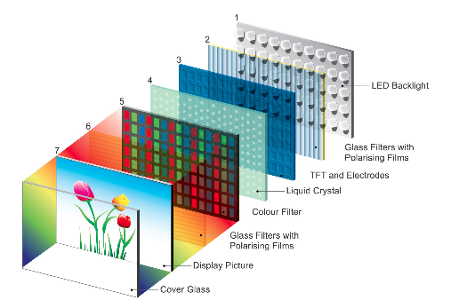**What is the LCD display?**

Liquid Crystal Display is 2 glass panels, with liquid crystals layer sandwiched between them, with 2 polarising filters sandwiching them. A backlight then shines light through these layers, using pixels.

Or one of the glass layers may have electrodes, and instead of a backlight there is a reflective surface

Liquid crystal is in a strange state of matter as it behaves like a solid and liquid. It can move freely, but its molecules are in the same direction. The liquid crystal’s purpose is to rotate polarised light

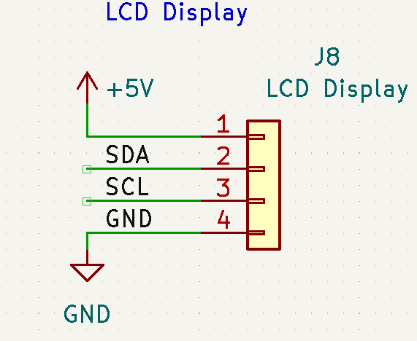

These two data lines are part of the I2C wire bus. In this context the master is the microcontroller, and the slaves are the peripheral devices (display or ADC)

SDA – Serial Data Line is used to transfer data

SCL – Serial Clock Line is controlled by the master; it synchronises the data transfer between master and slave

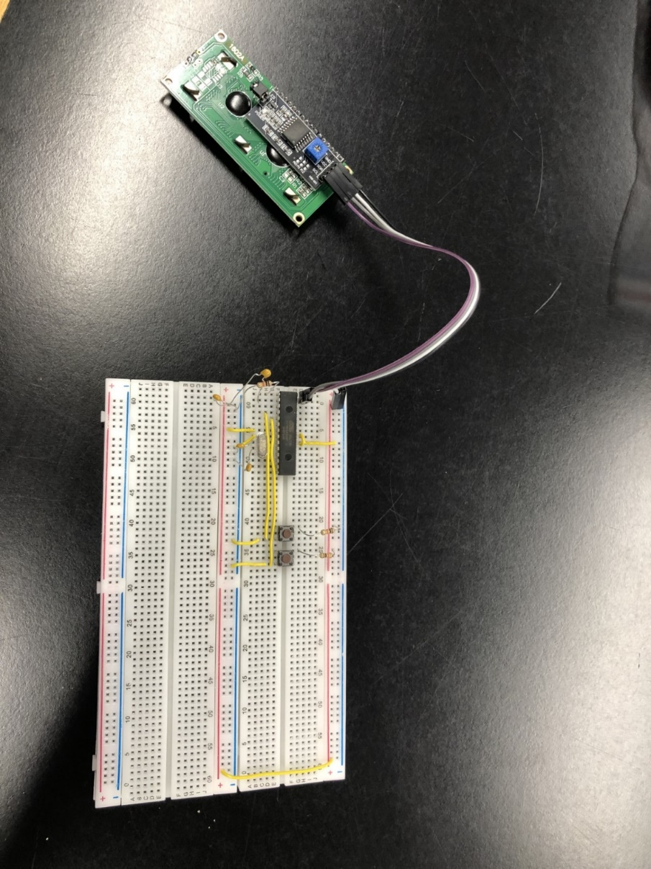

**Pull up resistors**

I added buttons and resistors to create a pull up resistor setup. For the MODE and RANGE pins on the microcontroller

These are switches that go from a logic-high to a logic-low, when a button is pressed. This is creating no error, as if the switch went from low-high, Electromagnetic interference may falsely trigger the button. Which would send a logic-high signal to the microcontroller.

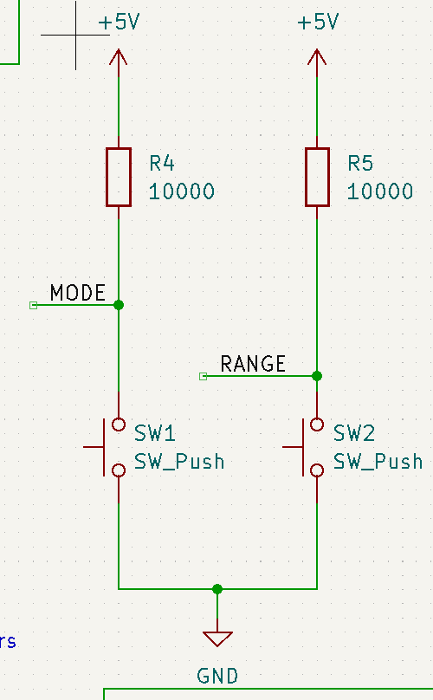The Microcontroller would use inverse logic in its code, as it would receive no voltage, to process the information

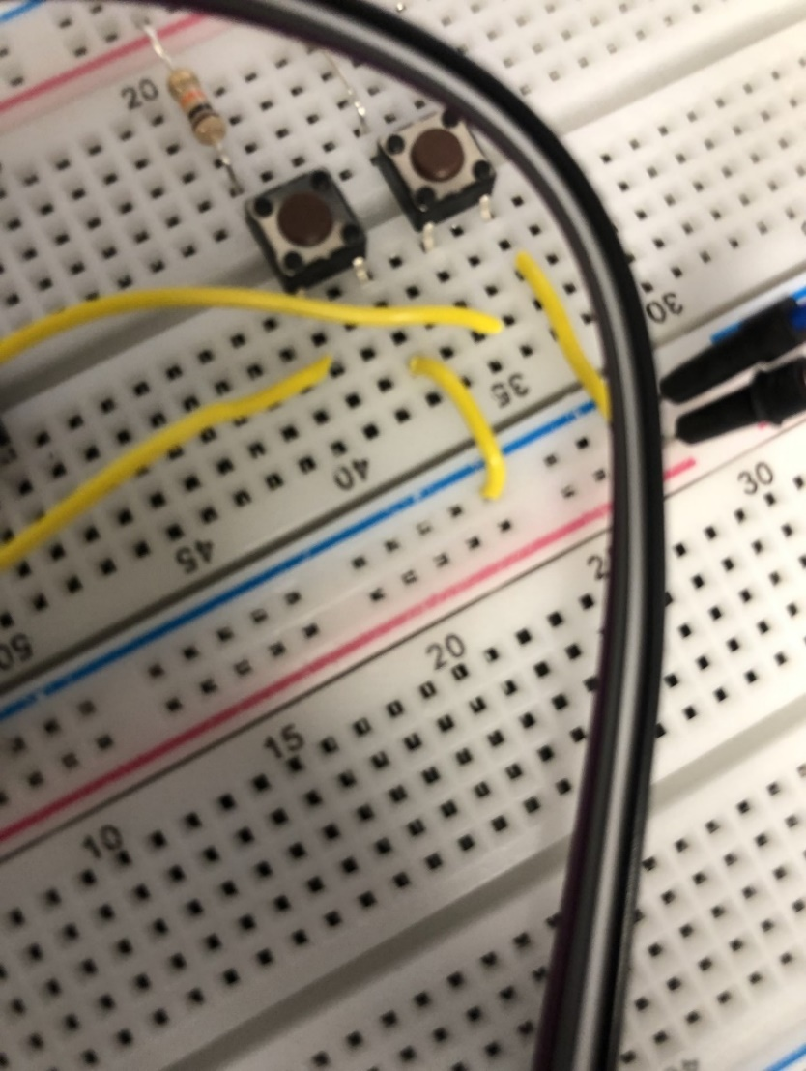

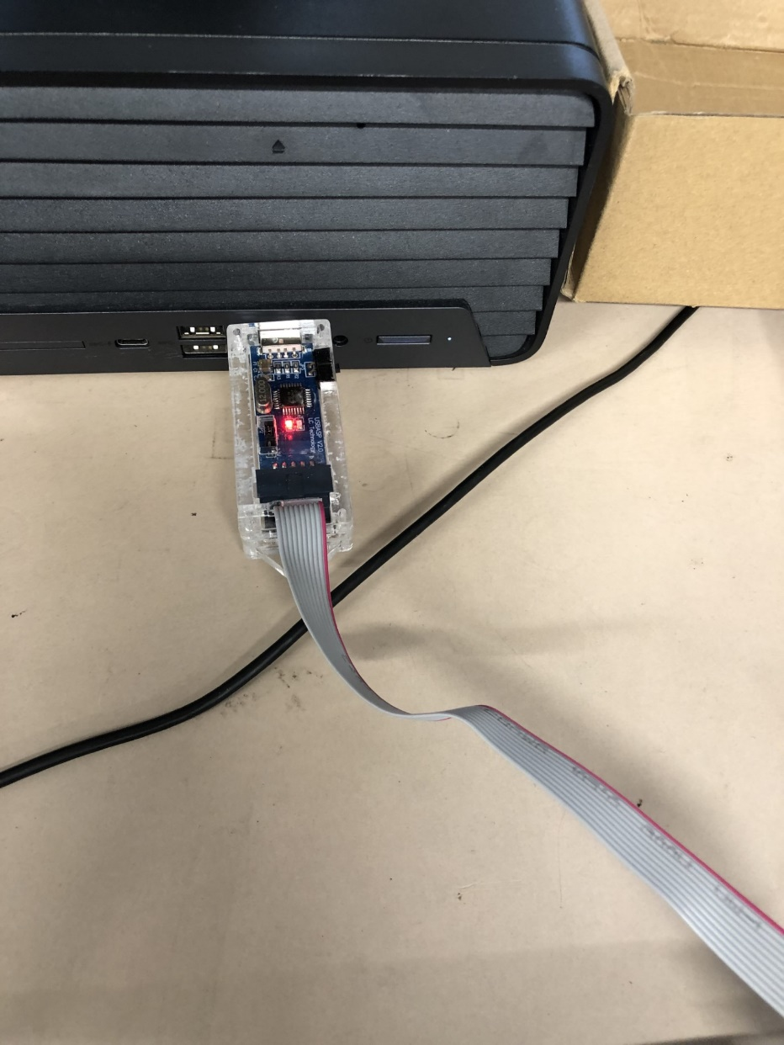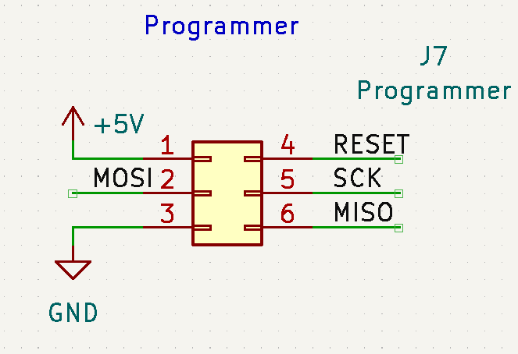Plugging in the programming code using a bootloader.

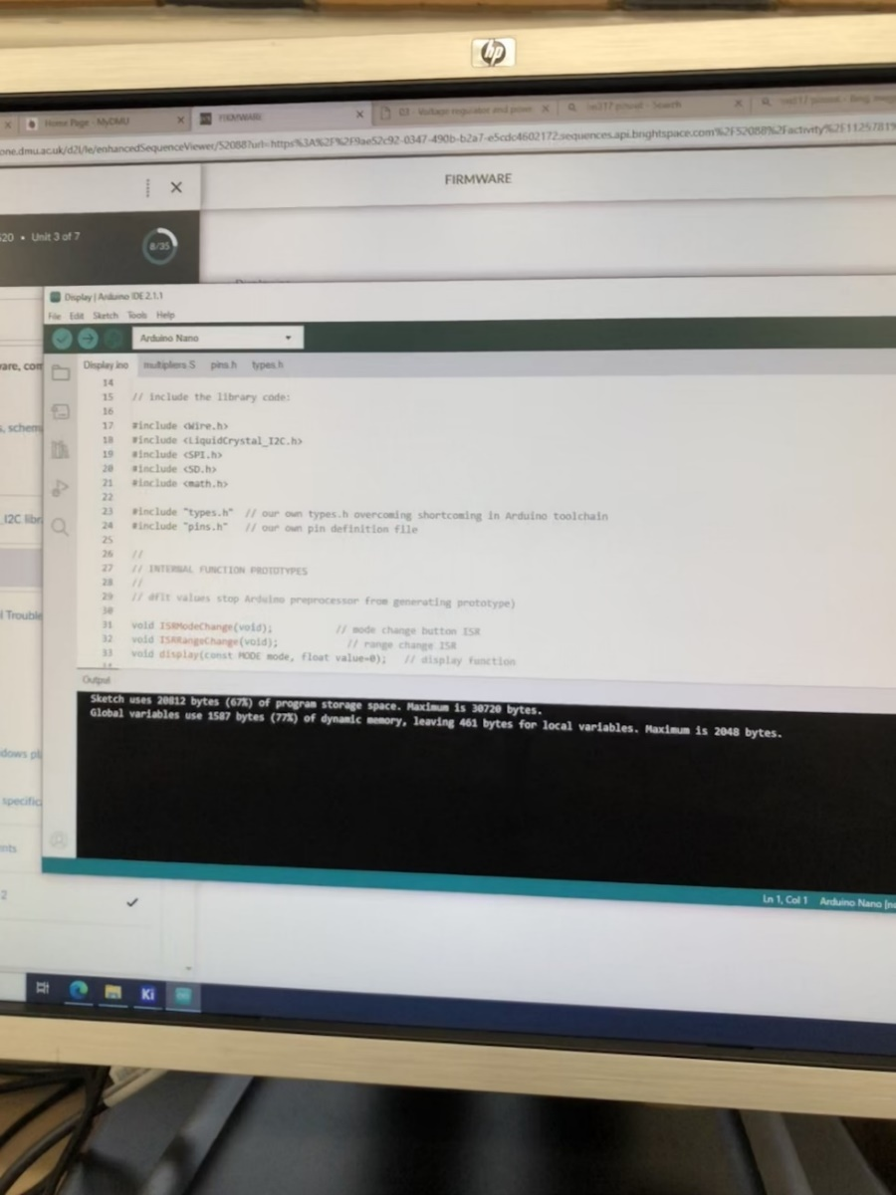Downloading (Burning) the code onto the bootloader.

This code would be the instructions for the ATPMEGA328p about how to manipulate the data being inputed (VDC in, VAC in), as well as outputting data (PWM).

I connected the the SCK, RESET, MISO AND MISO pins on the microcontroller. As well as connecting to the Vcc and Gnd lines for power. 6 connections in total.

MISO (Master In Slave Out) – Output from slave to master.

MOSI (Master Out Slave In) – Output from master to the slave inputs.

SCK (Serial Clock) – Control line by the master which regulates flow of data bits.

RESET – When this line is active, the microcontroller resets.

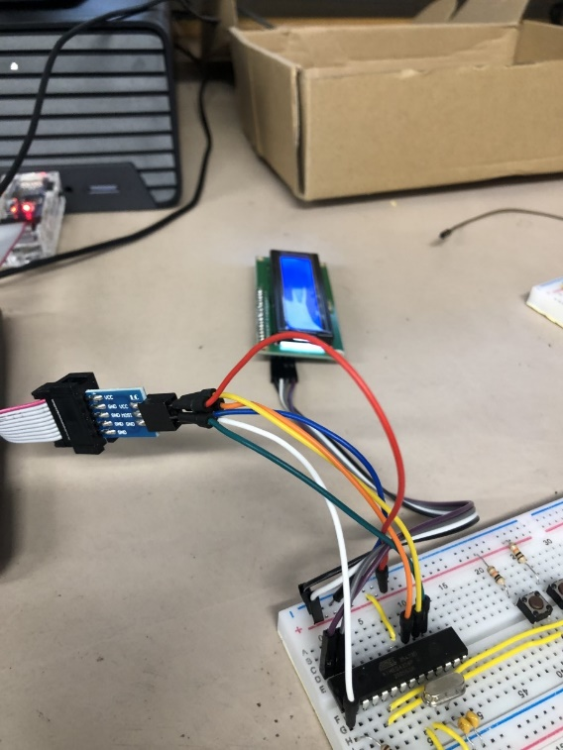

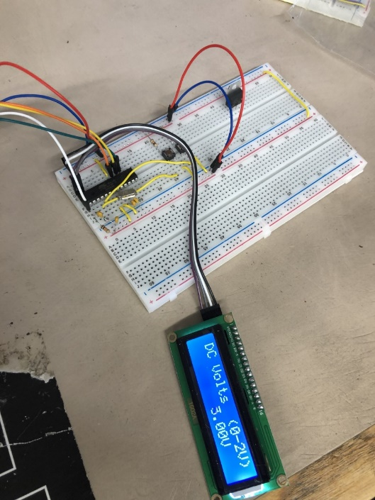The LCD display is now operating!

**Week 3**

**Overview**

This week I made a voltage regulator cirucit using the LM317. This outputs a stable voltage into the power rails of the device.

**What is the LM317?**

It is a positive voltage regulator that can output a steady voltage between 1.2V and 37V. It has Input, Output and Adjust pins.

The LM317 receives an irregular input voltage. Vin should normally be higher than the required output voltage to ensure proper regulation. Some of this energy will be dissipated as heat. Inside the LM317 there is a built-in reference voltage (Vref), typically around 1.25V. This reference effort serves as a fixed reference point for the regulation process.

To set the desired output voltage, you can use a resistor divider network connected between the output and the adjustment pin (ADJ) of the LM317. This network consists of two resistors R1 and R2, and the ratio of them determines the output voltage. By adjusting the value of R1 them you can set the desired output voltage.

The LM317 uses feedback from the tuning terminal to compare the output voltage to the reference voltage (Vref). It continuously adjusts the output voltage until the voltage at the adjustment pin matches the reference voltage. This ensures that the output voltage remains constant even in the presence of input voltage variations or load changes.

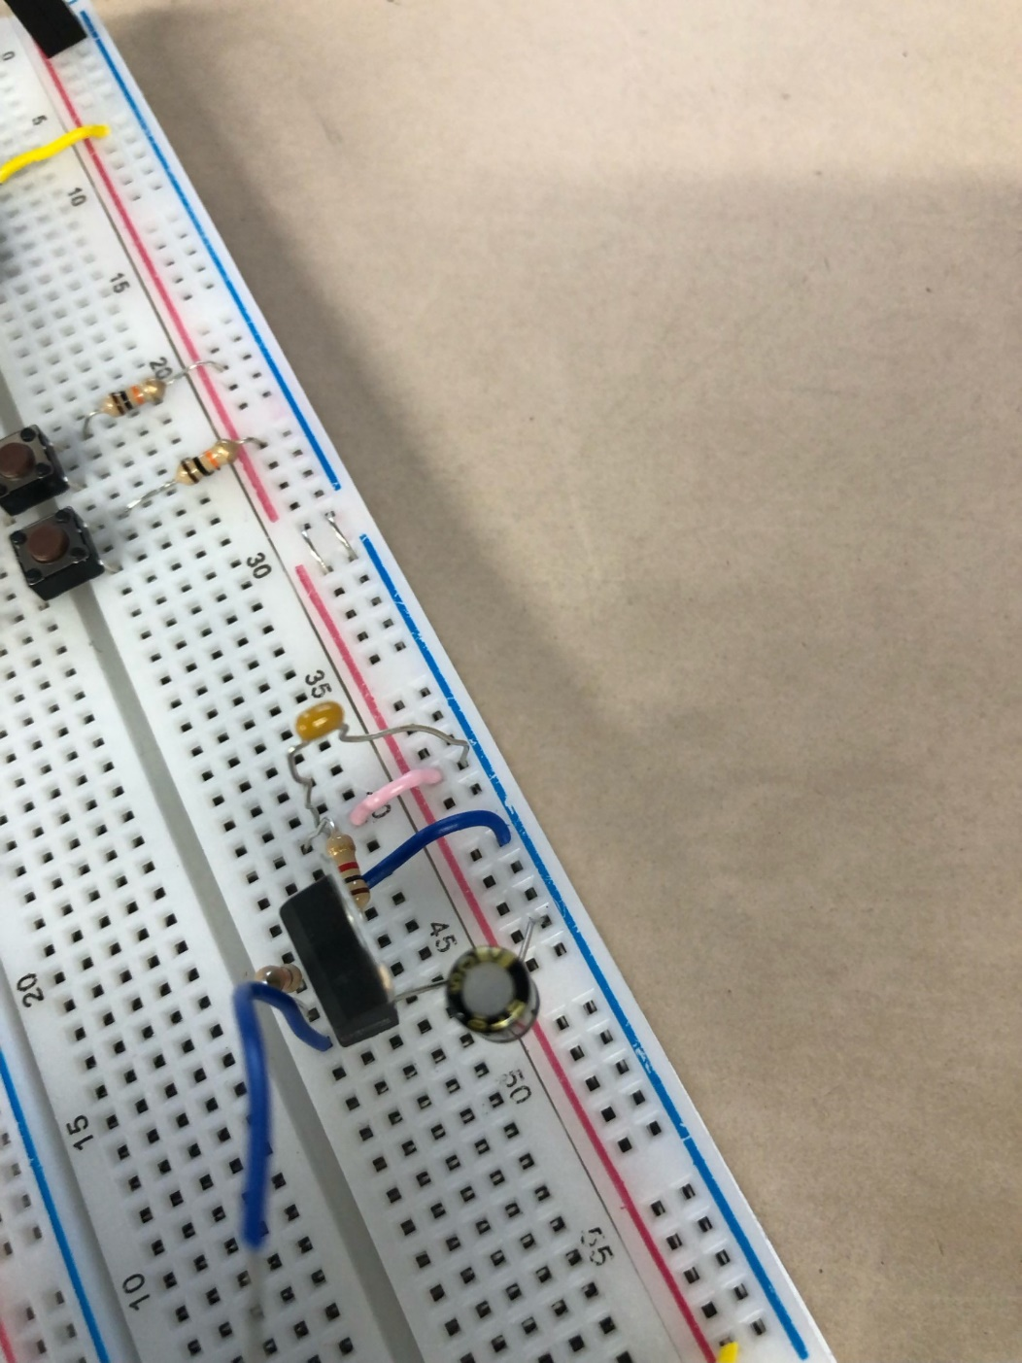

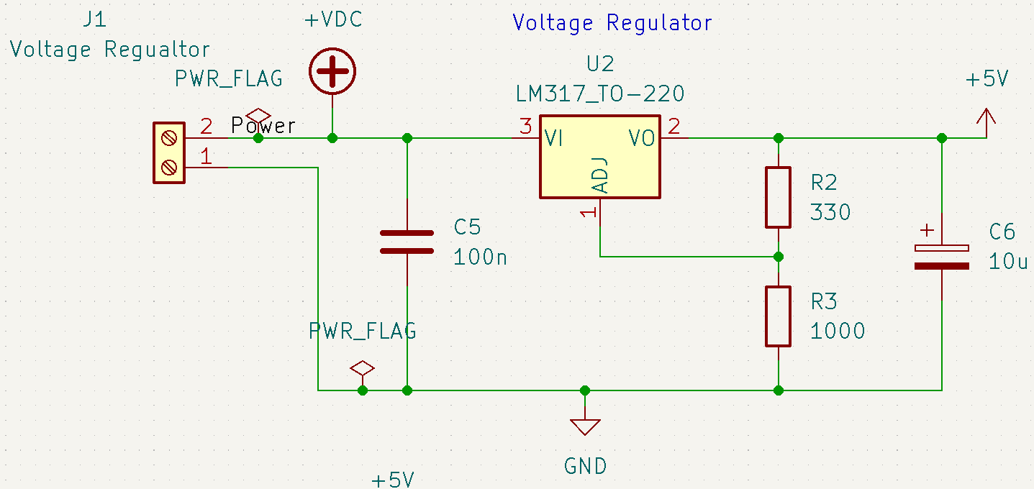

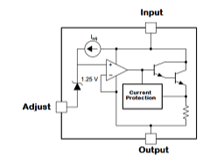

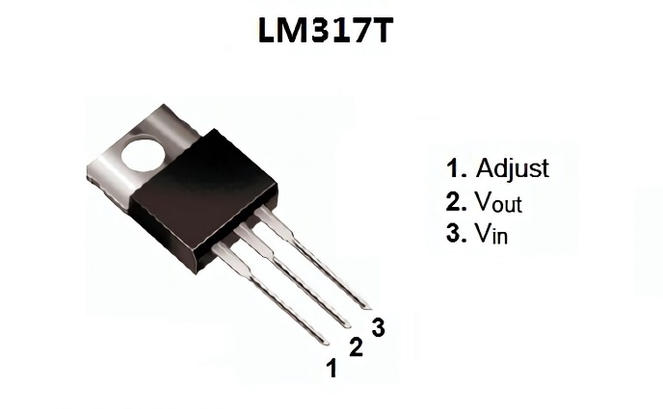

**Week 4-8**

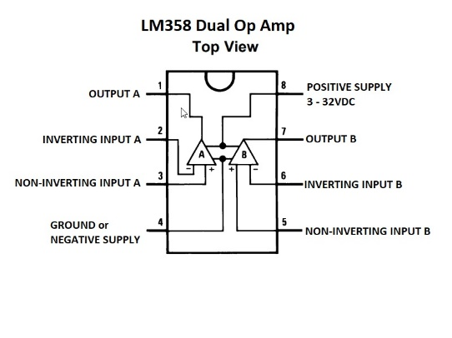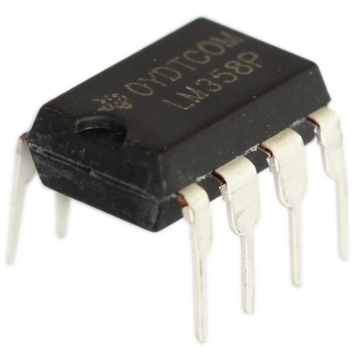

**What is the LM358?**

This is an IC that contains a two operational amplifiers. 2 pins for the power supplies. I am only using one operational amplifier though.

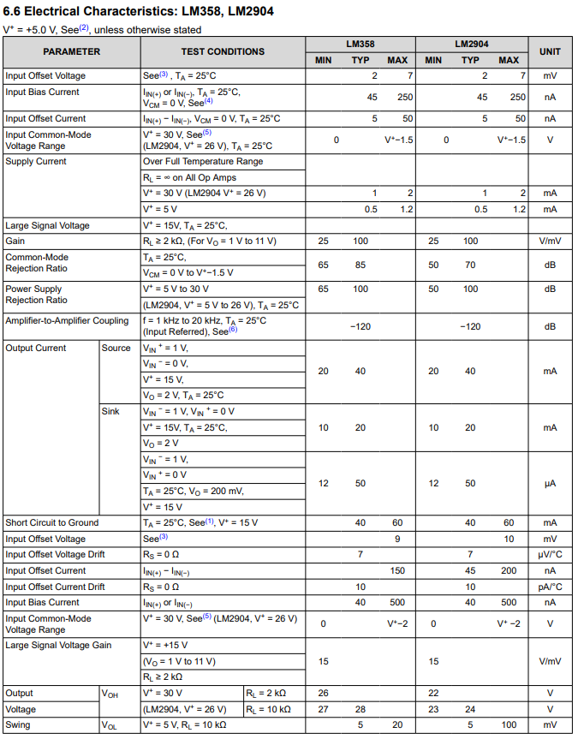**Datasheet for LM358**

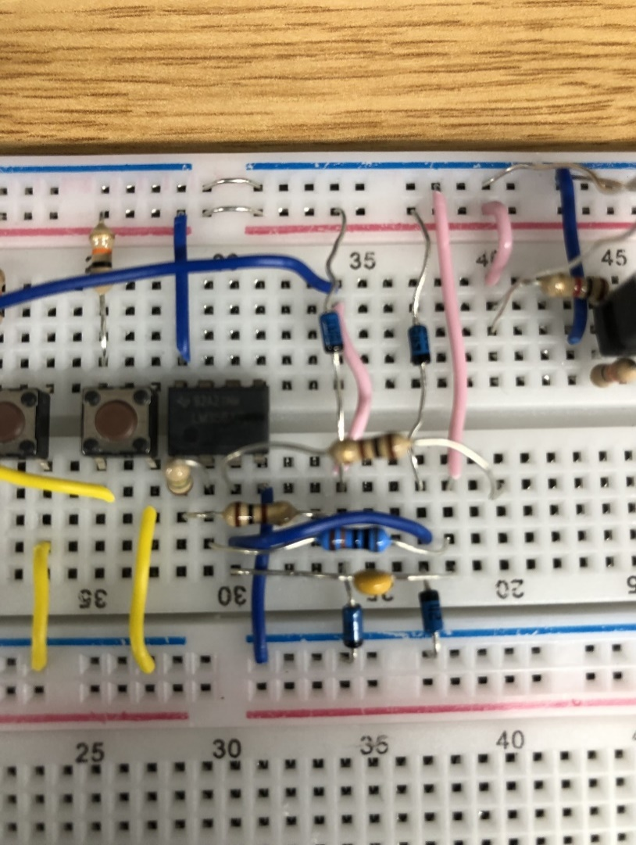Here is the circuit.

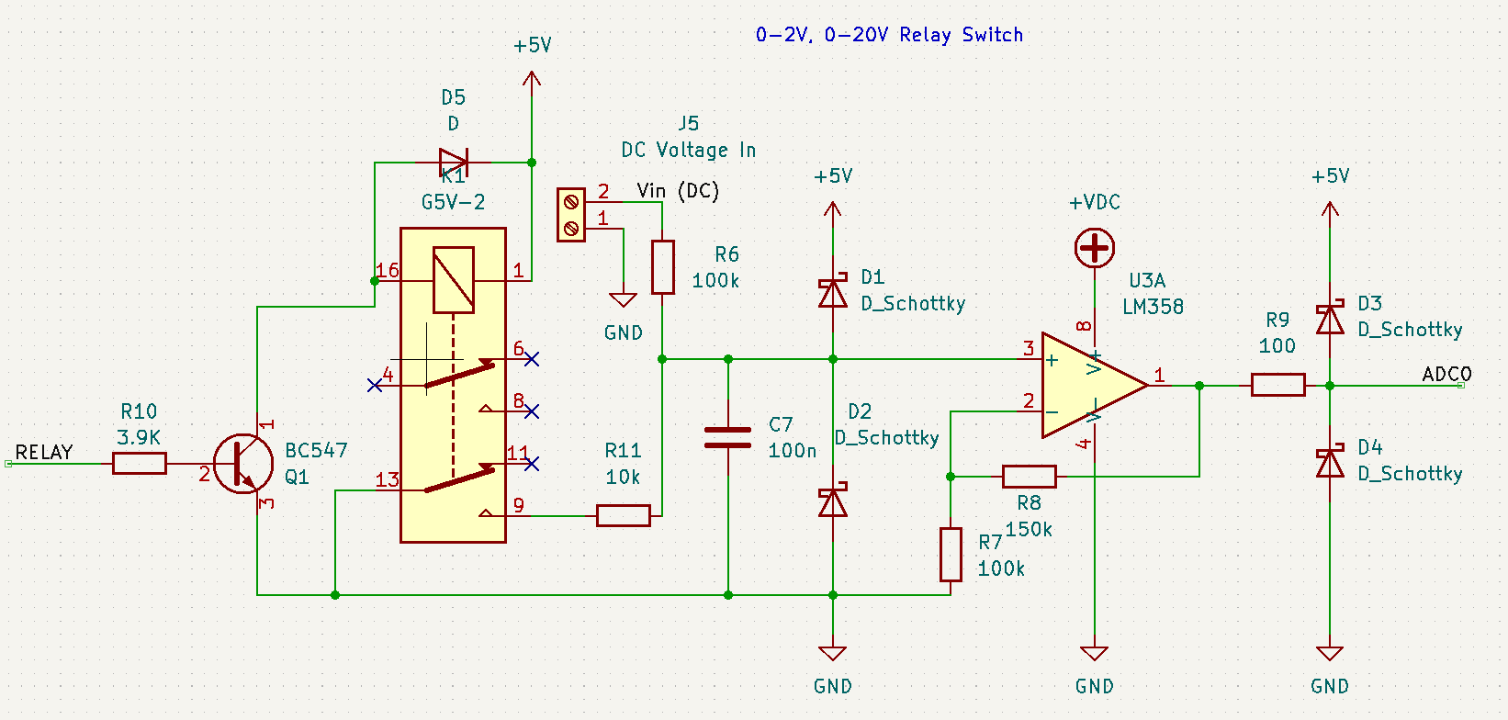

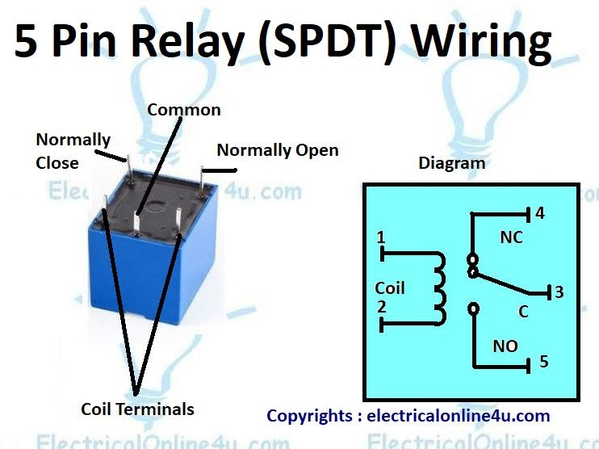**What is an Electrical Relay?**

This is and electromagnetic switch that uses activated depending on if enough current is flowing through it. There is a coil that behaves like an electromagnet, and pulls the metal switch when it is energised. There are 2 states the relay can be in.

Some components may have multiple relays in them, such as the one I am using now.

It has many uses in electronics and can be implemented in many automatic set ups.

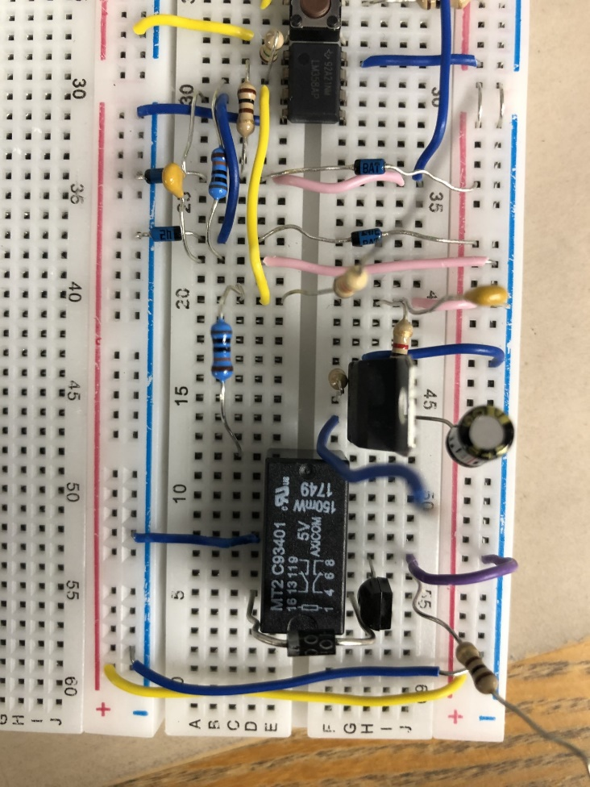

On this multimeter on a breadboard, I will be using the relay to switch between the ranges 0-2V and 0-20V.

A voltage divider circuit has been created between 10k and 100k resistors. The relay makes a connection to ground to activate this potential divider.

By default, the coil is energised when power is supplied to the board. This means that the switch is connected to relay pin 111, when the relay line has current.

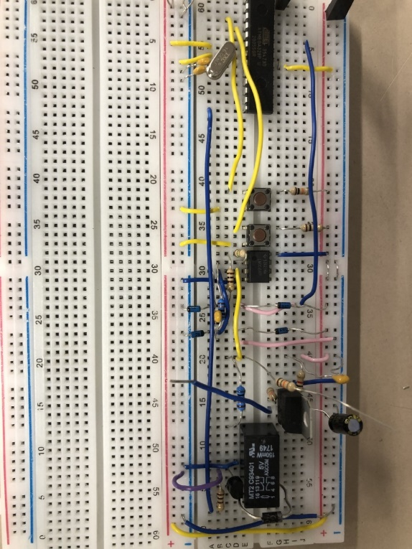When the range button is pressed, the microcontroller gets a change in state on the RANGE pin, so the RELAY pin on the microcontroller sends a command to the transistor.

This is the gate of the BJT, so current can flow through it. This BJT is acting as a switch, when it is closed, it short circuits the rely coil to ground, which de-energises it. This releases the pin 9 on the relay to ground which completes the potential divider circuit.

­

**ADC ( Analog to Digtal Converter)**

This converts continous voltage signal to binary signal, for the microcontroller to read. In this case I am using Operational Amplifiers along with a few other supplementary compnents.

**Week 9-10**

**What is the ICL7760?**

This supplies creates a negative voltage supply by supplying a voltage, as well as adding more components. It should output a negative copy of the input voltage.

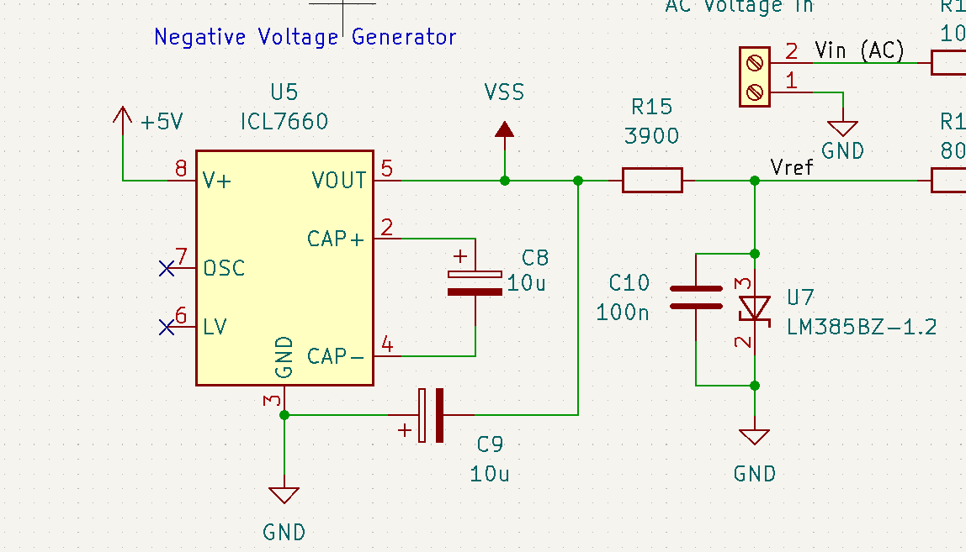

Ac you can see this circuit has 2 10 microfarad capcitors, 1 100 nano farad capacitor, 1 3900 ohm resitor and an lm385 rference voltage gebrator.

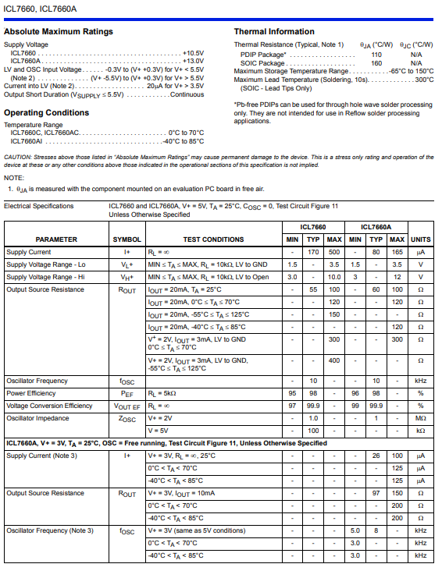**ICL7760 Datasheet**

**Negative voltage rail**

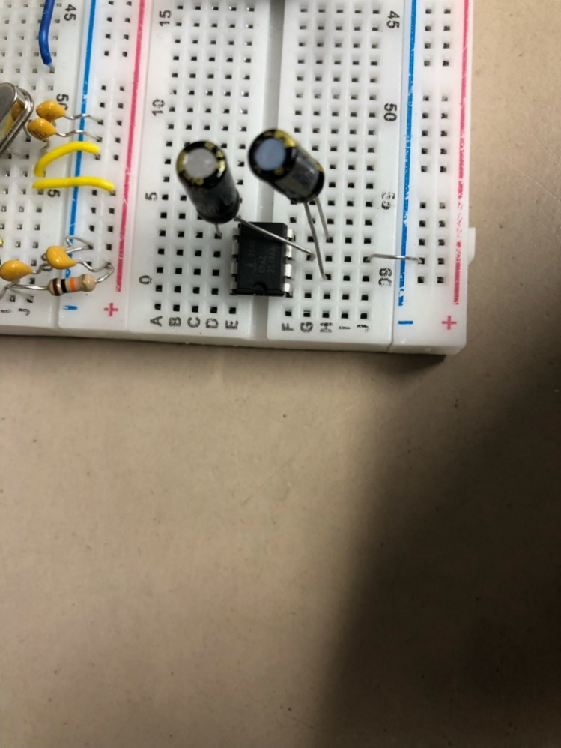This will be used to provide negative voltage to pin 4 of the operation amplifier in the AC voltmeter. This op amp is used as the ADC in the AC voltmeter.

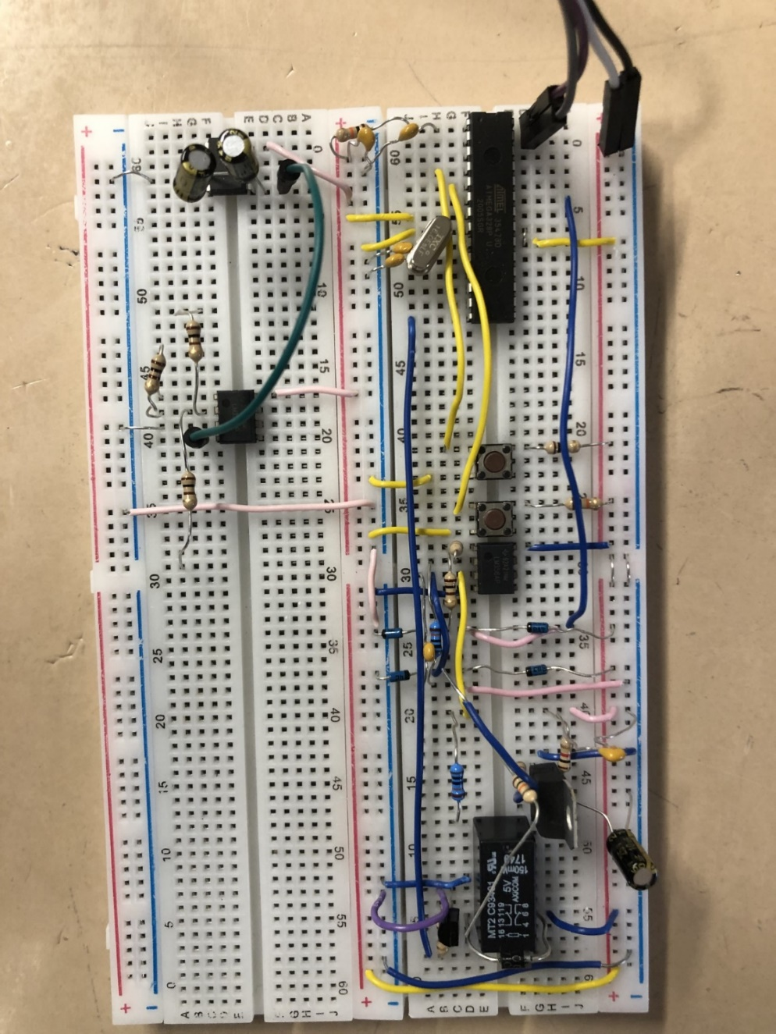

Image below shows my updated breadboard

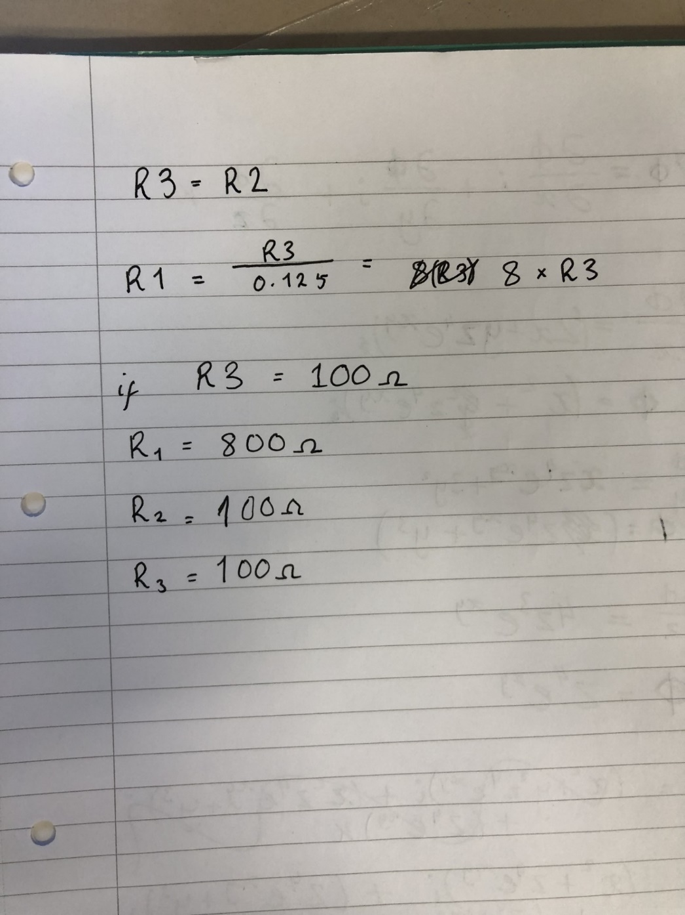**Week 16**

In this week I will complete what I haven’t finished, so I can be up to date.

For R1 I had to use 820 ohms resistor. This was on the AC generator.

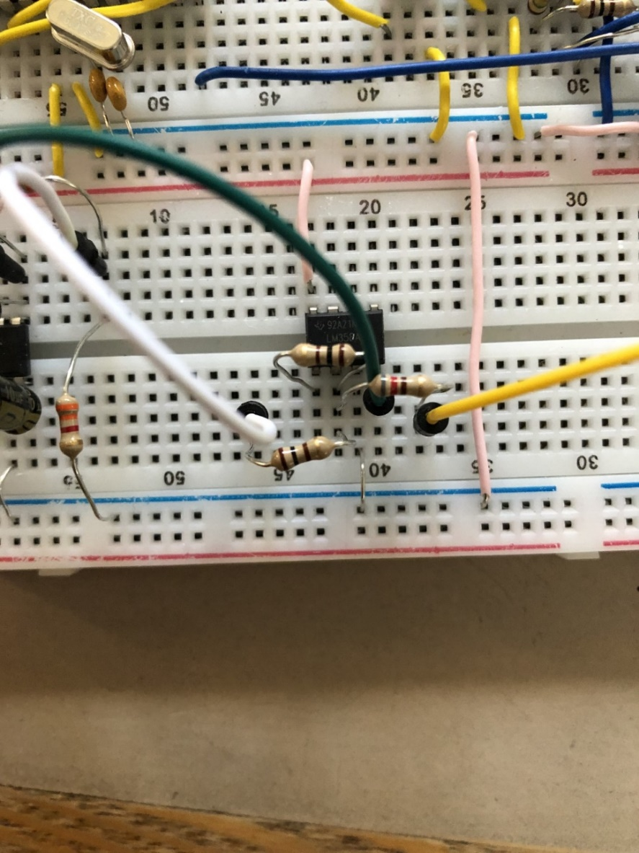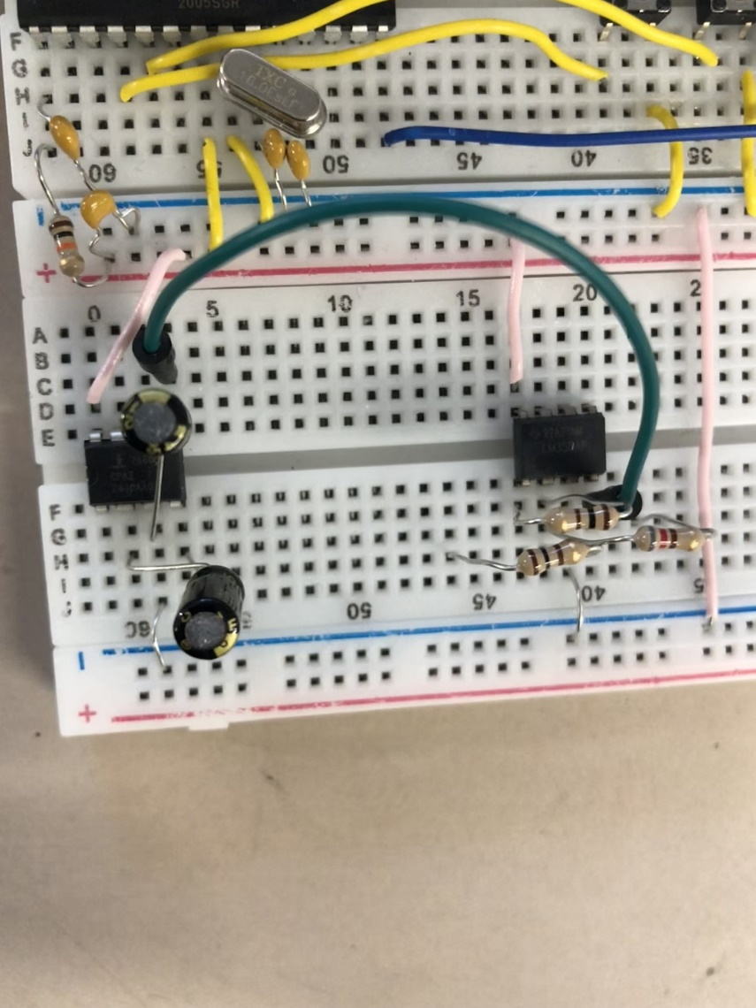

**Week 19**

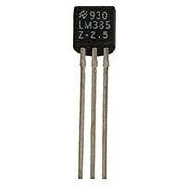**LM385**

This is creating a reference voltage, so the AC signal can be positively offset.

This would be for the AC voltmeter, so the continuous AC signal doesn’t get clipped by the ADC (op-amp), as AC have both positive and negative voltage values.

The ADC will read the whole AC signal from 0-5V, and can send a digital signal to the microcontroller which can then be sent to the display.

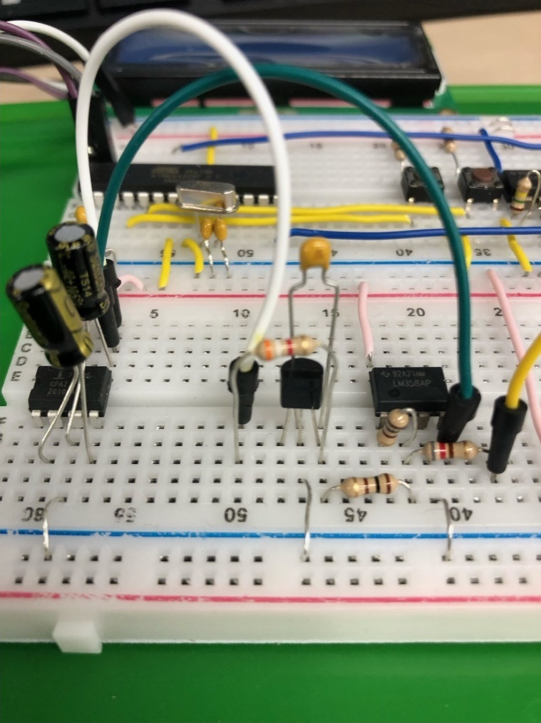I completed the negative voltage rail and the AC voltmemeter.

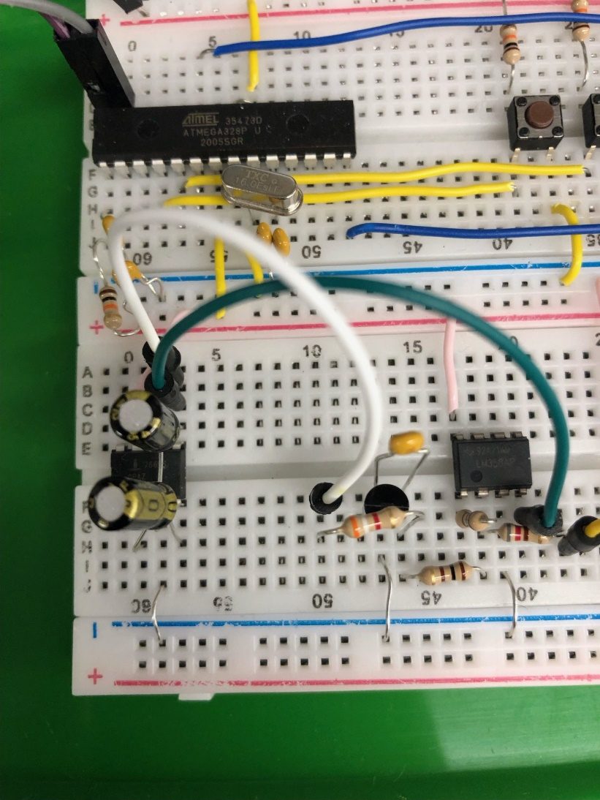

**Week 20**

**Low-Pass Filter**

This is an active Sallen-Key low pass filter. It filters out unwanted frequencies, based on the resistor and capacitor values that are placed in tandem with the op-amp.

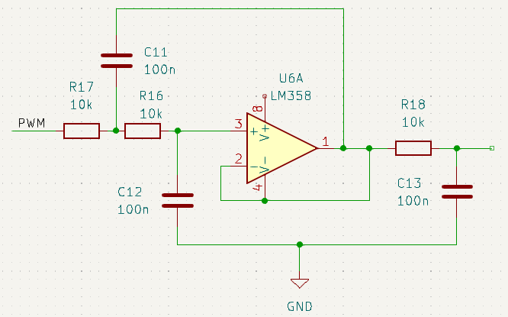

Calculations

Here are calculations for the cut off frequency for an active low pass filter.

10000 Hz is the cut-off frequency that I want.

1/(2*π*10000hz) = 0.0000159….

7.5nF * 2200 ohms = 0.0000169

I had to change it because there were no 7.5 nF capacitors. But there was 4.7 nF capacitors. I used 330-ohm resistors because it gives the closest value.

4.7nF * 3300 = 0.00001551

This result is close enough to the original constant, but not as close as my original calculated one.

Below is a complted circuit of a sine wave generator on the breadboard.

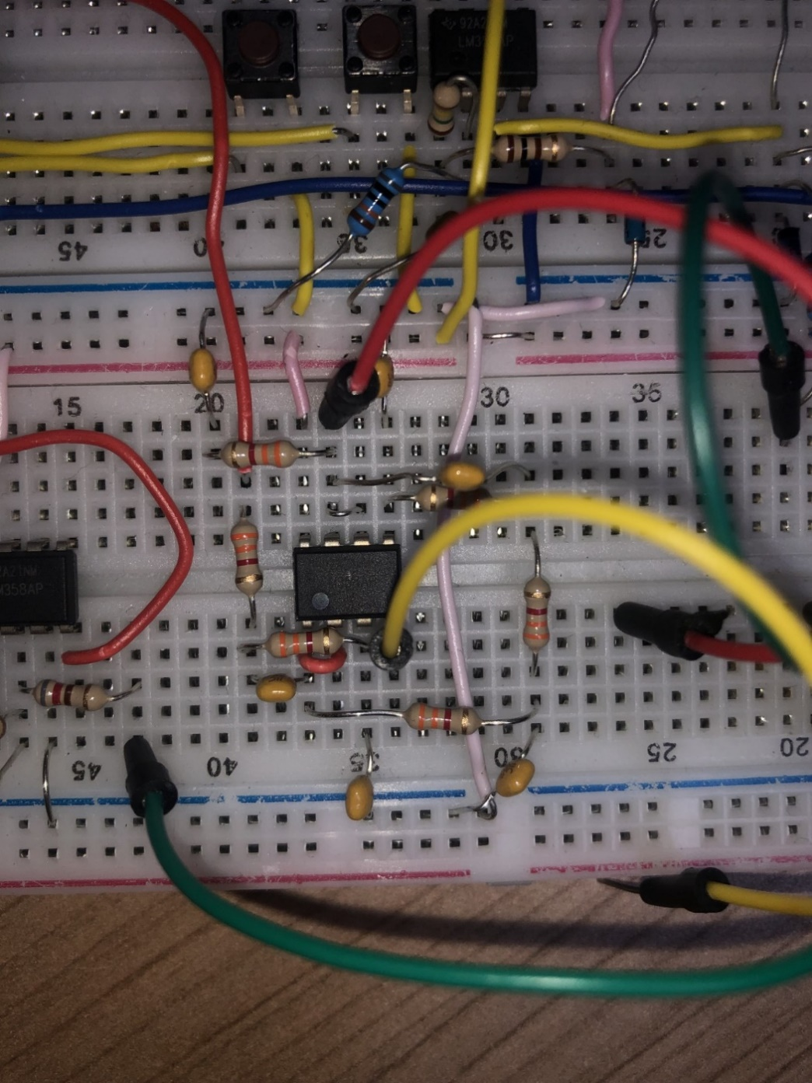

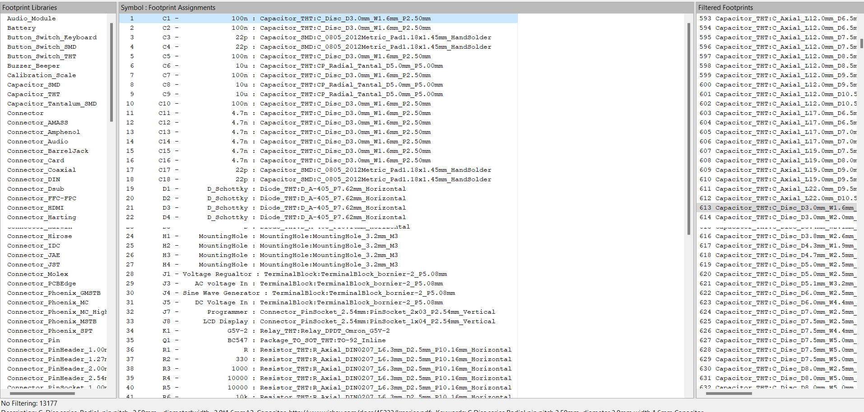I added all the footprints to the components

All the nets and finished

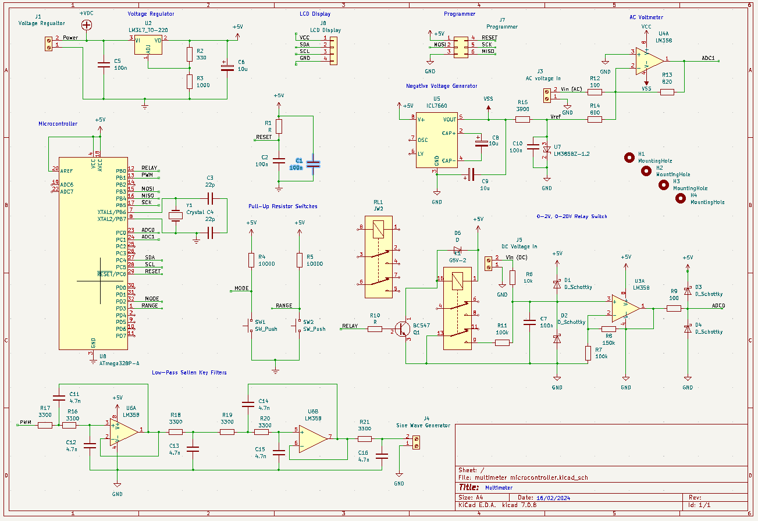

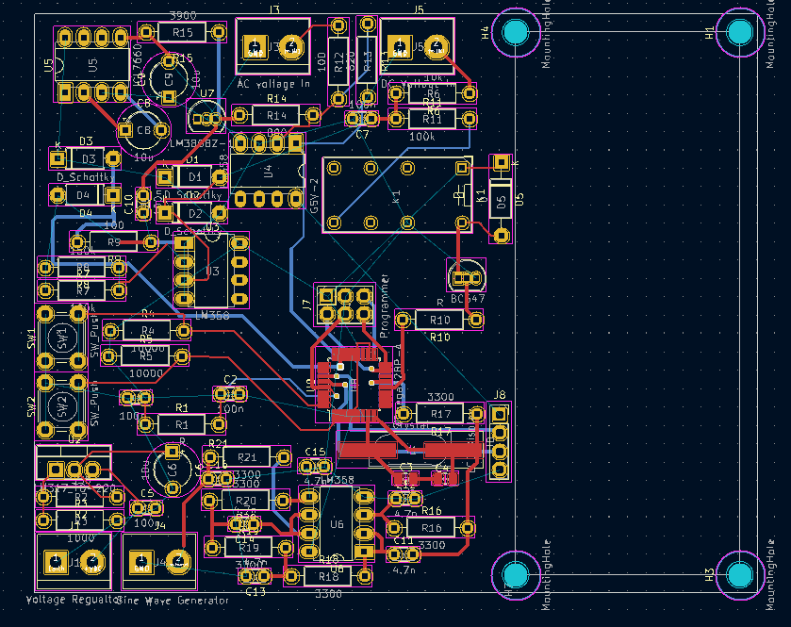Here is the completed PCB, in the PCB editor:

Here is real life theoretical view.

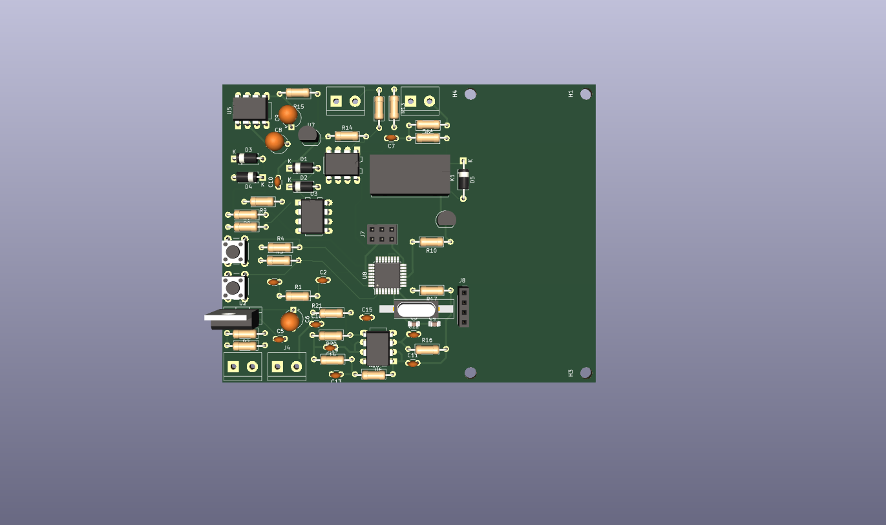

PCB has been delievered from China.

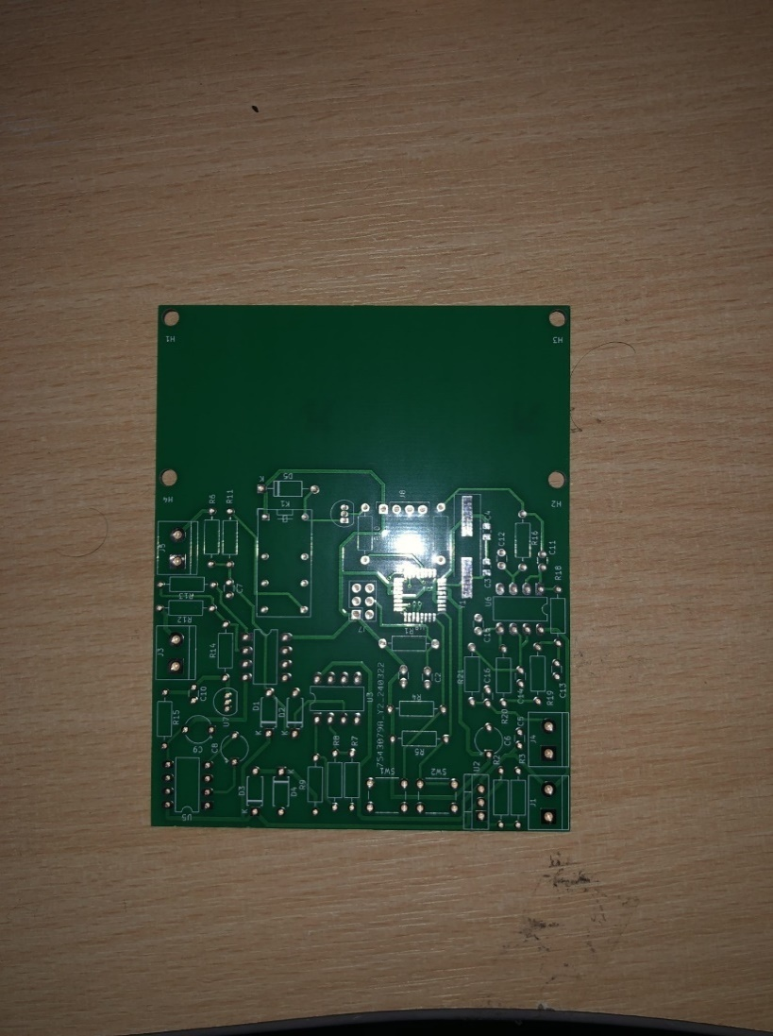

**Week 31**

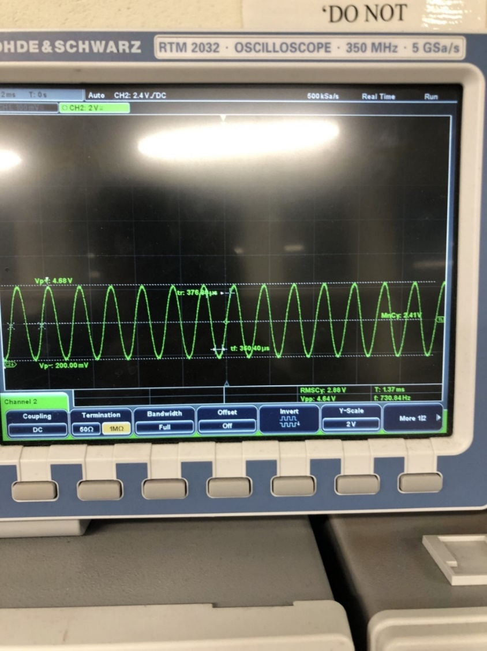The Sine wave generator in action.

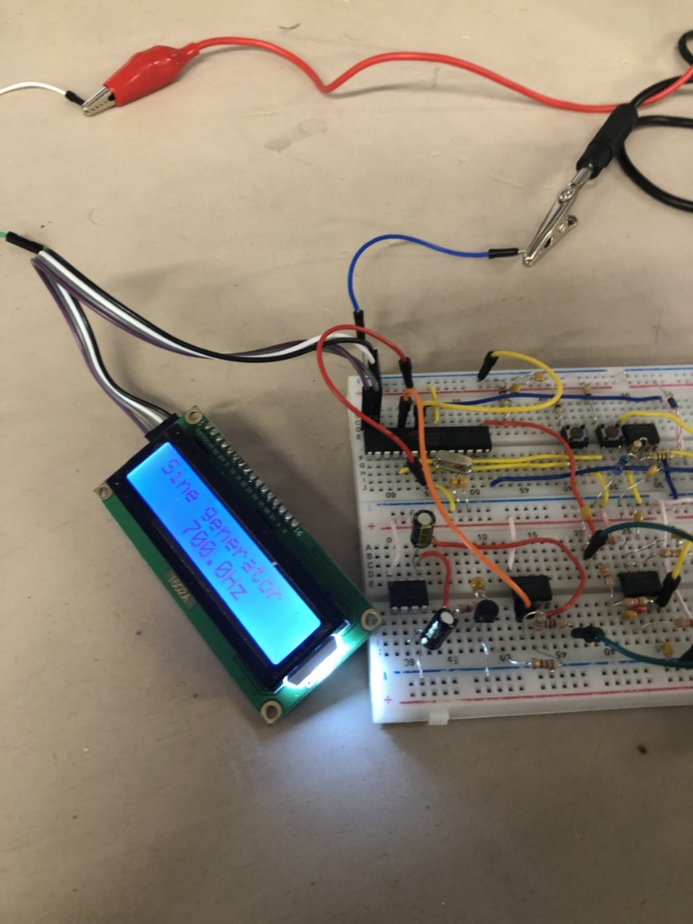

**Breadboard conculsions**

Sine wave generator works

DC Voltmeter doesn’t work

AC Voltmeter is dodgy, offset reading

**MOVING ONTO PCB NOW!**

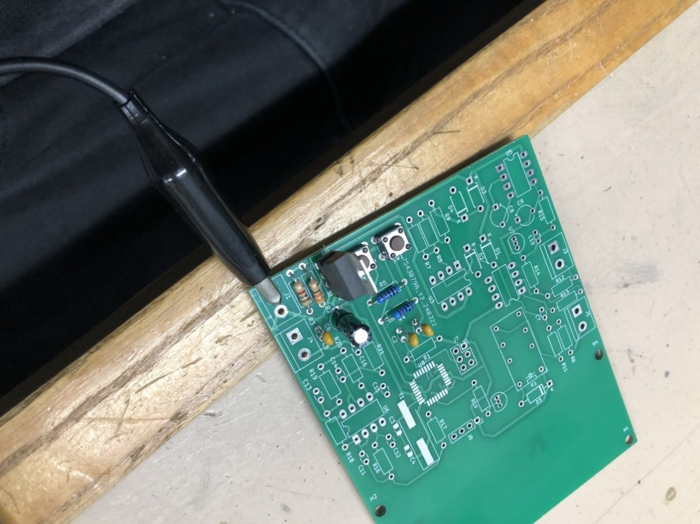Added the voltage regulator ciruit to the PCB.

1st attempt of loading the bootloader.

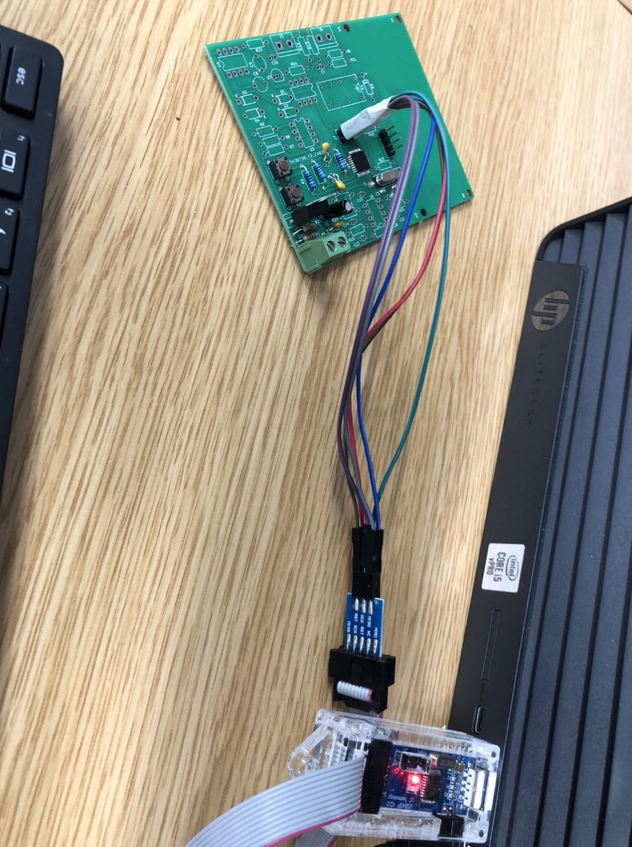

Major mess up with the crystal oscillator circuit. I tried installing the software, and the programmer didn’t load up.

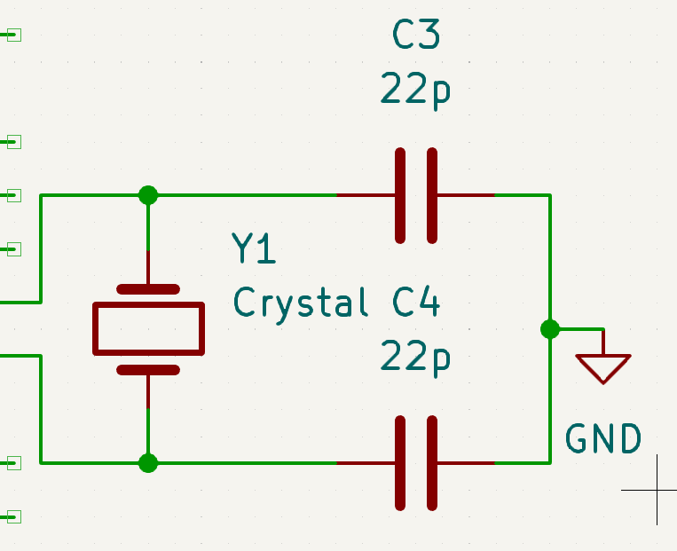

My schematic had the programmer pins in the wrong order as well. But this didn’t matter too much, as I used some jumper cables to re-route the connections.

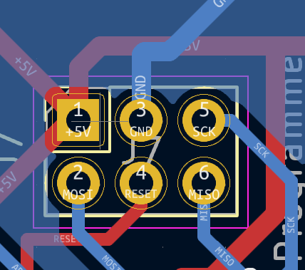

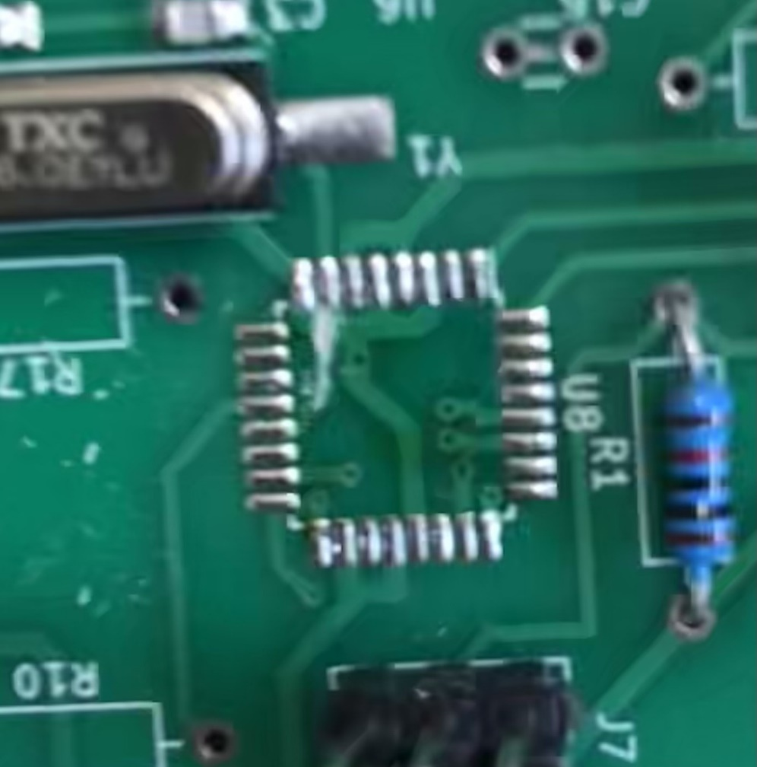Cut the ground track, as this was preventing the microprocessor to boot up.

Added a new connection to ground between the two 22nf SMD capacitors.

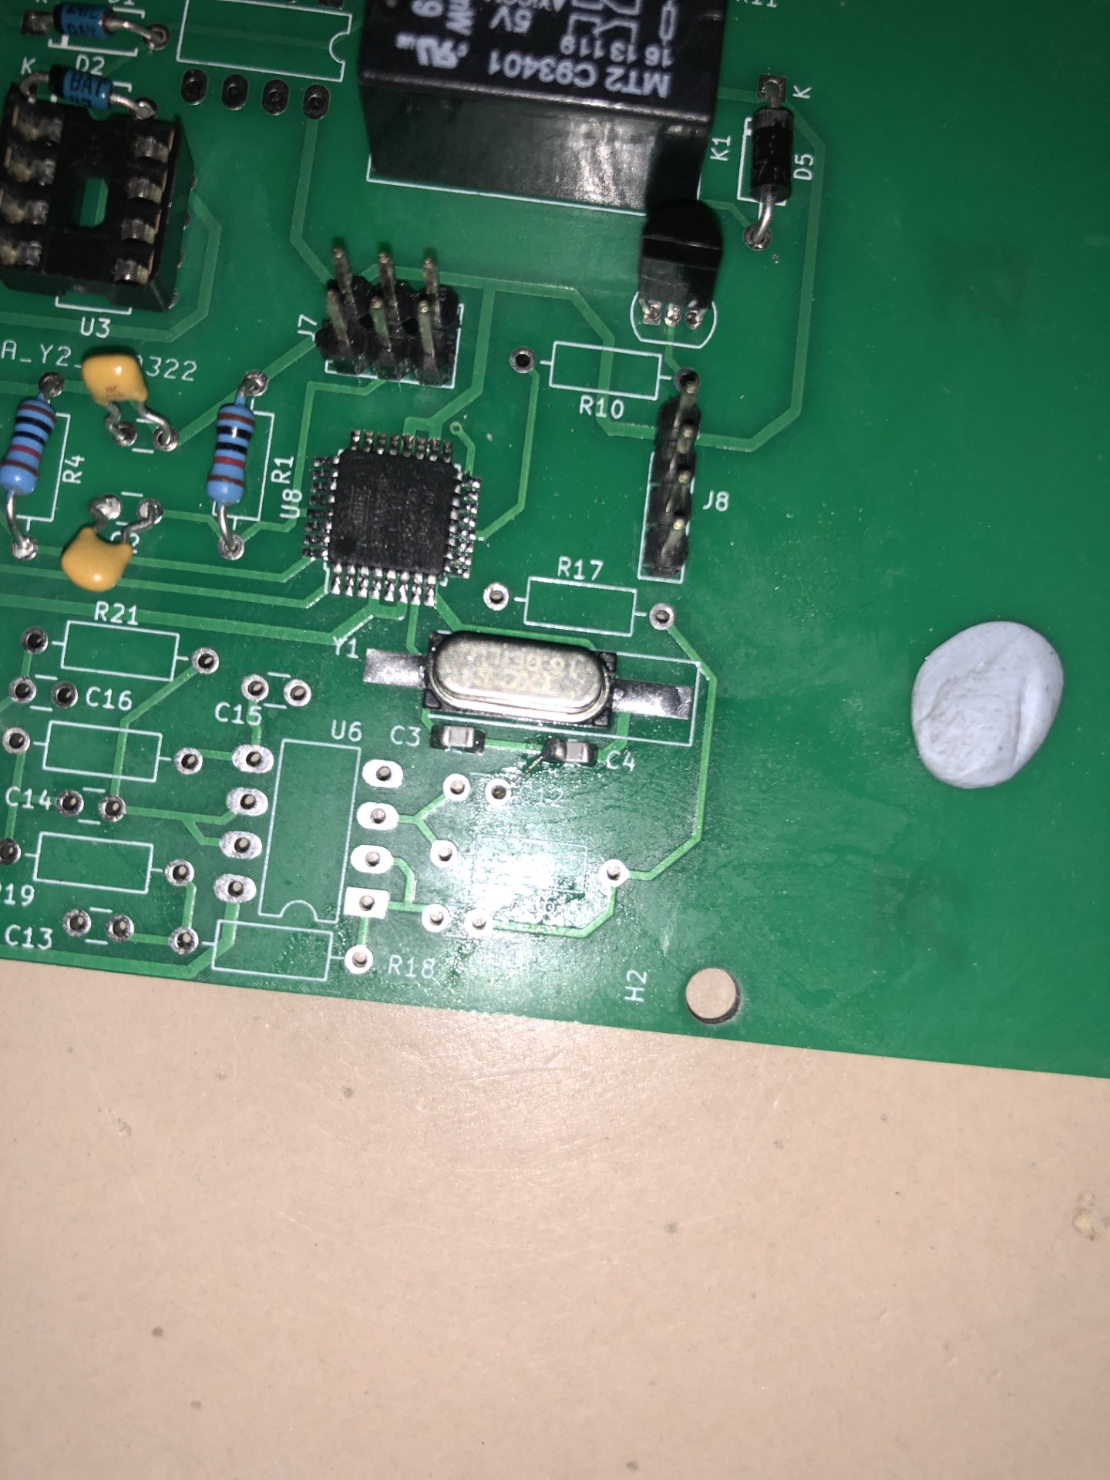

The bootloader uploaded the code to the microprocessor, and the display now works. Problem solved!

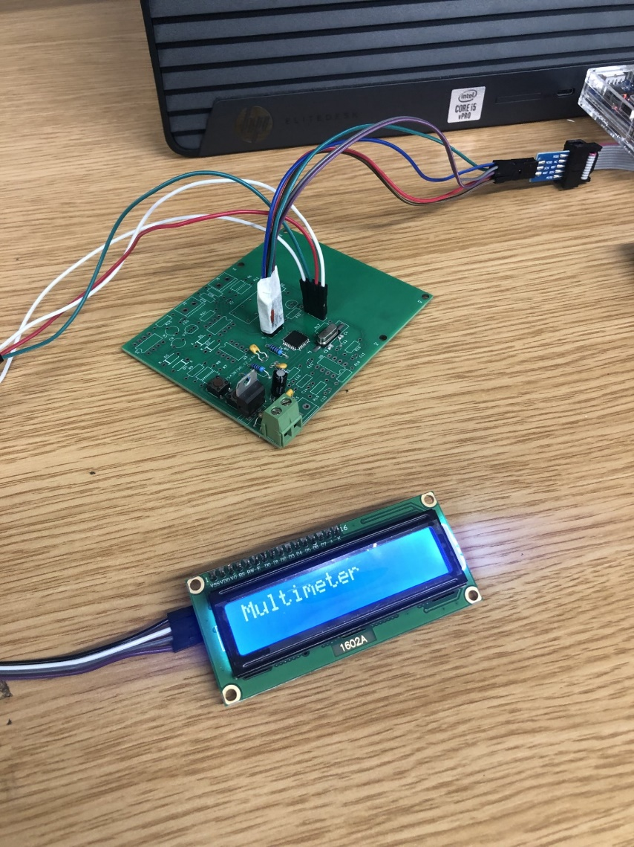

Installed the DC voltmeter circuit.

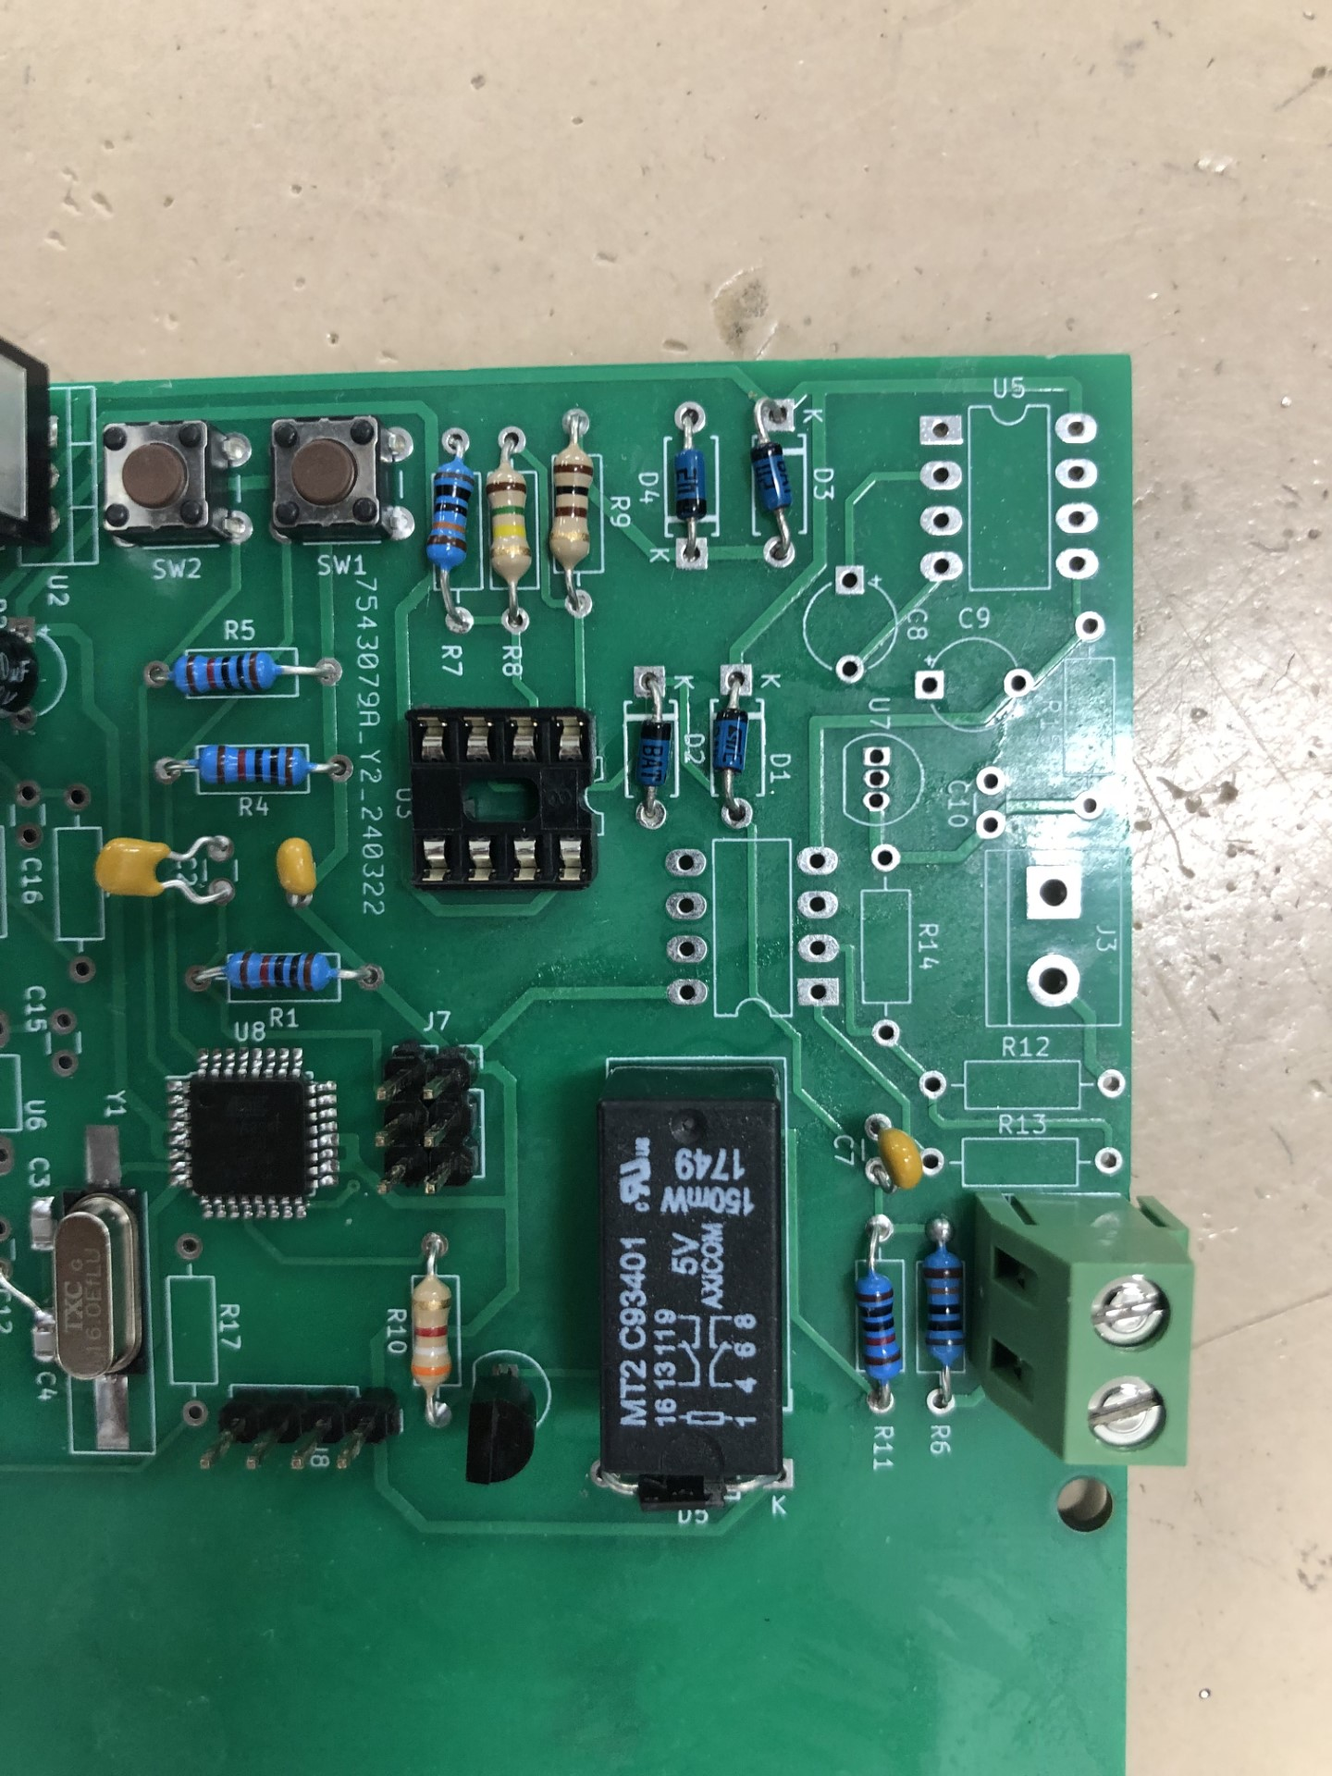

The DC voltmeter circuit is unresponsive.

**02/05/2024 (demo date)**

I done my demo today and the PCB turns on but the DC voltmeter doesn’t work. I didn’t have the sine wave generator and the AC voltmeter on the board as well.

My resistor values are wrong on the AC voltmeter, as well as the schematic had some mistakes. These being the names of certain connections being incorrect.

But these mistakes were small compared to the DC voltmeter being a failure. I’m unsure what is the issue with it, as it wasn’t working on the breadboard prototype as well.

**Conclusion**

I’m not proud of my result, but I think it could’ve ended worse. Part of this is my fault as I dint spend a lot of time on this project as I should’ve done, and I haven’t published parts per milestone. I also left a lot of things until last minute.